The Complete Mortgage Marketing Kit
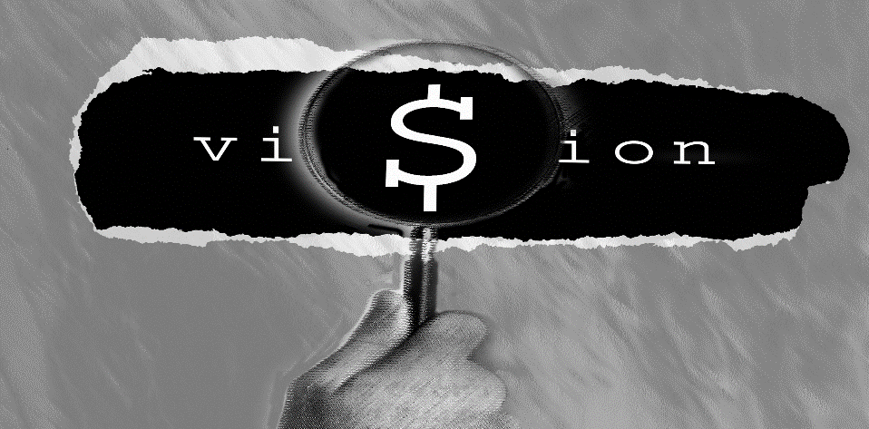

Important Notice

The Complete Mortgage Marketing Kit
contains copyrighted materials and is
intended only for the personal use of
registered owners.
Owners of branch versions can direct the use for all brokers/loan officers working out of their physical branch up to a maximum of ten individuals. Do not remove copyright indications from pages before duplication.

Note: The documents are Microsoft Word®, PowerPoint® and Publisher® documents. You must have these software programs to manipulate the files. The Publisher® documents are also presented as PDF® files as well. This format cannot be manipulated but may include areas which can be personalized.

© All rights reserved OriginationPro/The Hershman Group
www.originationpro.com success@hershmangroup.com
(703) 222-6612 (800)581-5678 Fax (703) 222-8815

